Welcome!
Date
Name
Spouse
Address
City
State Zip _________
Email

Please Contact By
❑ Card  Phone  Visit

Telephone Best Time to Call
Home ______________
Work ______________

Guest: First Time Second Time
Are you a church member: yes no
Church
City, State

Circle Appropriate Age/Grade Group(s)
Preschool: Ages: B-1 2-3 4-5
Children: Grades: K 1 2 3 4 5 6
Youth: Grades: 7 8 9 10 11 12
Adults: Ages:18-29 30s 40s 50s 60s+

How did you learn about our church?
Newspaper Friend Yellow Pages Mail
Other

I am a guest of:

New in the Community? Yes No
Names & ages of children at home

Weekly Service & Activity Schedule

April 29, 2018
9:45 a.m. Sunday School
11:00 a.m. Worship Service
6:00 p.m. Evening Service

Week of April 29, 2018
Wednesday 6:30 pm……………..……….Meal/Bible Study
Friday 6:30 pm……………….…………..Men’s 42 Night

May
6……………………………….New Commandment Kids
6………………….Assoc. Music Festival – Chappel Hill
13……………………………………………..Mother’s Day
13……………………………..New Commandment Kids
20……………………….…Graduate Recognition Lunch
24………………………………Make & Take Card Class
There is a community wide meeting today @ 3 in the Fellowship Hall to continue planning the benefit for Scott Ruthven.


Independence Baptist Assoc. Music Festival First Baptist Church Chappell Hill May 6th @ 5:30 pm

Operation Christmas Child Gift for April

Stuffed Animals


Animals have to be small so they fit in the shoebox with other items.

Graduate Recognition Covered Dish Lunch Sunday May 20 After the Worship Service

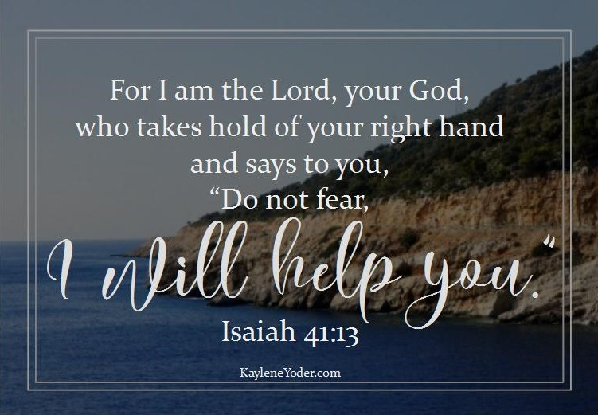

Knobbs Springs Baptist Church

April 29, 2018

Church Information:

KnobbsSpringsBC.com KnobbsSpringsBaptist@gmail.com

1662 CR 305, McDade, Texas 78650 512-273-2743

David Atwood, Pastor Cell 512-470-5098

Patti Radford, Office Manager Cell 512-968-7821

